Project1: IoT security

The following two figures show the protocol stack for IoT and the representative protocols. In this project, we will investigate some of IoT security issues. One is the IoT-oriented secure transport layer protocol which will be widely installed on IoT devices. The other is the access control issue for IoT service provisioning.

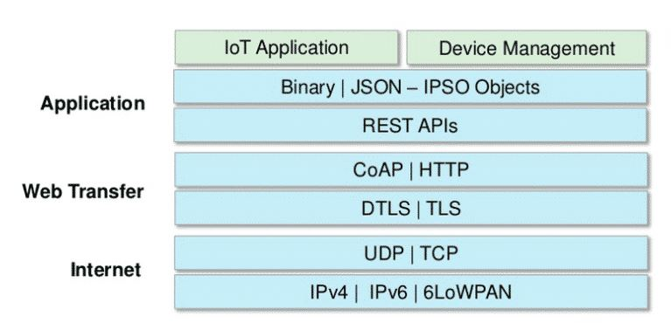

Fig.1 protocol stack for IoT

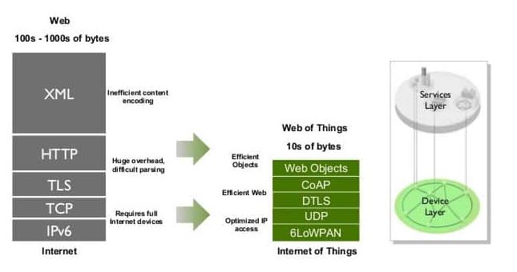

Fig.2 comparison of IoT stack with traditional protocol stacks

1. DTLS is the secure transport layer protocol which was specially designed for the use of IoT devices. It is specified in rfc 6347 as an IETF standard. The other paper summarizes the rfc 6347.

* [The Design and Implementation of Datagram TLS](http://citeseerx.ist.psu.edu/viewdoc/summary?doi=10.1.1.74.6613)
* [Rfc 6347, Datagram Transport Layer Security Version 1.2](https://tools.ietf.org/html/rfc6347)

Studying these documents, answer the following questions:

(1) Why do we need DTLS other than TLS?

(2) How different is DTLS from TLS?

(3) (optional) explain what CoAP is?

2. In the lecture of week 10, we learned the architecture of the identity and access management. By studying the following paper, answer the following questions:

(1) Compare the various approaches for IoT access control.

(2) How does this proposed secure network architecture in this paper solve the problems we raised in the class?

* [A Secure Network Architecture for the Internet of Things Based on Local Authorization Entities](https://ieeexplore.ieee.org/document/7575852)

3. Answer the following questions:

(1) What is OAuth?

(2) How does this protocol solve the issues we raised in the class?

(3) (optional) Can you compare OAuth with other protocol for the access control framework? What are the differences of OAuth with other protocols?

* [OAuth-IoT: An access control framework for the Internet of Things based on open standards](https://ieeexplore.ieee.org/document/8024606)

You can use these papers as baseline papers, and refer to other related documents for your understanding.